An unusual zoom meet
Me and my parents had gone to South Africa during the holidays and we rented a small old rusty house for quite some time as we were stuck there because of coronavirus. My parents had gone out for shopping in the local markets over there. My school was going on so I was trying to do my English homework but I just couldn’t because my phone was going ting ting ting ting ting. Who was sending me so many messages? I did not get that much homework from school, it did not stop, it was driving me mad. I threw aside my book and slammed my hand on the phone angry and irritated. A person had sent me forty six messages on Gmail!!!!!!!!!!!!!!!!!!!!!!!!!!!!!!!!!!!!!!! The person had not written his name, it said ‘‘unknown’’. It was 46 invites to zoom! All of them were same and the password was “comeifyoudare8004”. Eeek!

I tried to delete all the messages but by mistake one link got clicked and I was admitted into the meeting immediately as if the person was waiting for me. The profile photo was of a man with several scars and cuts scattered across his face he had a hood and there was a big tattoo of two knives in a cross on the side of his neck
A chill ran down my spine and suddenly he switched on his camera. I yelped at the sight of a blood stained floor, there was a leg of a young girl covered in blood, I was frozen on my chair, too shocked to do anything. Beside there were hooks with knives of 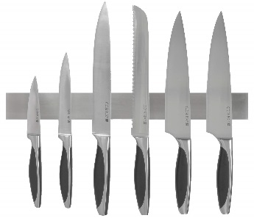different sizes hanging on them. A rough hand with some cuts reached out to the sharpest and biggest knife, a terrifying high pitched laugh echoed the room as the hand waved the knife in front of the camera. Suddenly the lights of my room started flickering which made the scene even more petrifying. There were wolves howling and spiders crawling across 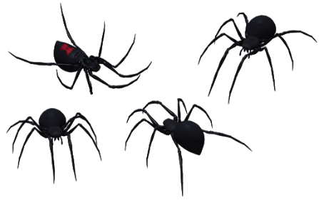the floor. It was a terrifying sight. Then, I saw the man legs following the spiders out of the house. They led him to a dark place covered with trees, he came to a very strange tree which was certainly hiding something, a gush of blood came and the man ran away back to his hut. He suddenly said “ verrrry verry preeti foto maadaam vaaie daun’t yoo sveech aun yorr veedeeo und sho mee yaur faiss?” I did not reply. He continued ‘‘Shaalll I sow oo maie faiss?’’, He showed his filthy shoes and the camera went up to reveal his skinny legs and blood splattered clothes followed by his neck with a necklace of something that looked like small bones. Just when he was about to show his face, I , at last came to my senses and found the red LEAVE button and left the meeting hurriedly. I wiped my sweat and heaved a great sigh. Good that I did not see his face now I can forget this but……………… suddenly there were footsteps approaching the room and the door creaked. ‘‘WAIIY YOO LEBT DA MEETEENG MAADAAM?’’ asked a gruff voice ‘‘EET DRAUVE MEE MAAD’’, I turned around to see the horror of my life.
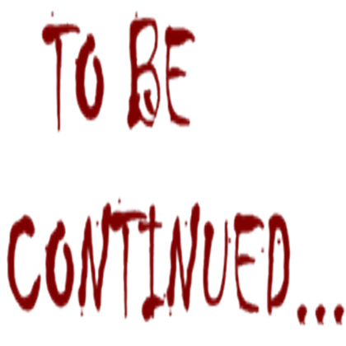

-Sanaya Agarwal

